**Project Output Screen Shots**

1. Home Page of FlyAway

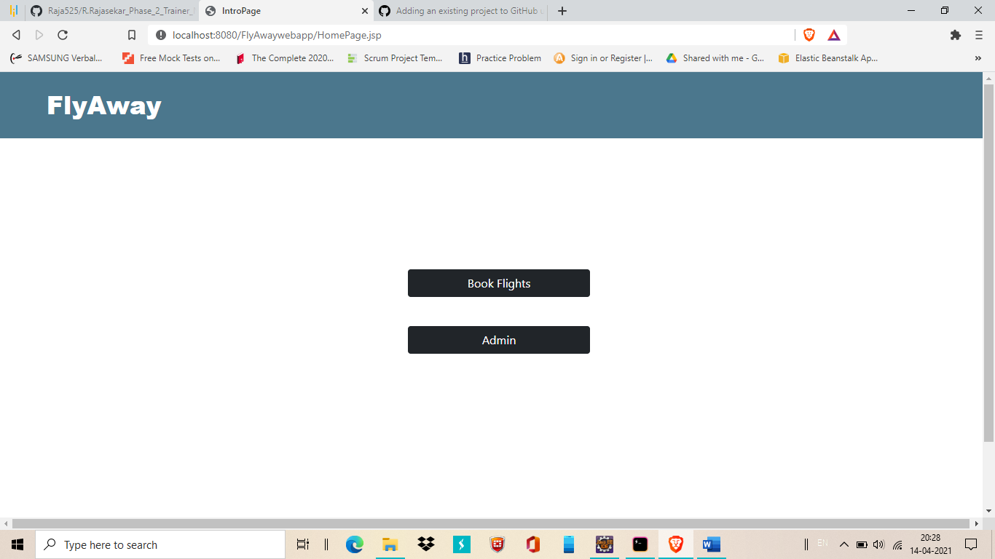

2.Click on Admin it will redirect to admin login page

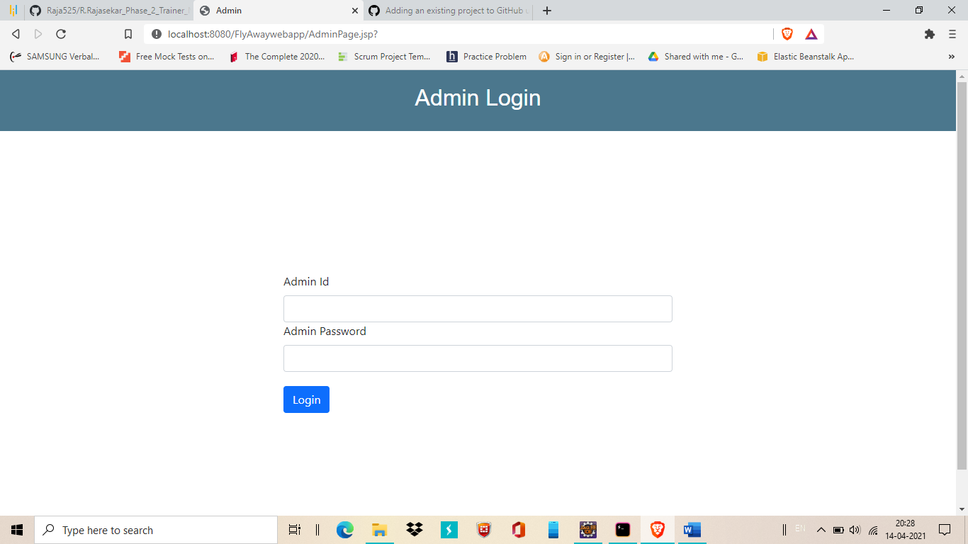

1. After enter valid credential it will redirect to admin dashboard

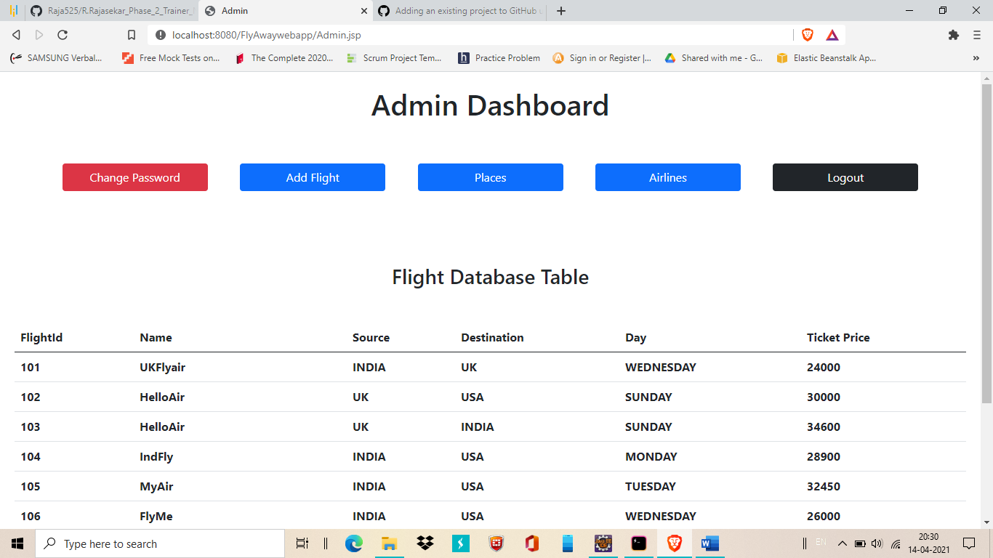

4.Change password

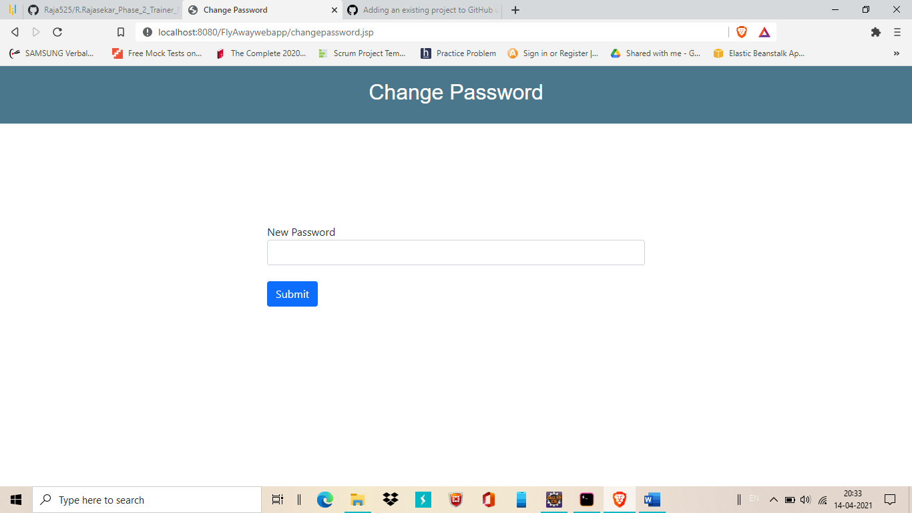

5.Add flight

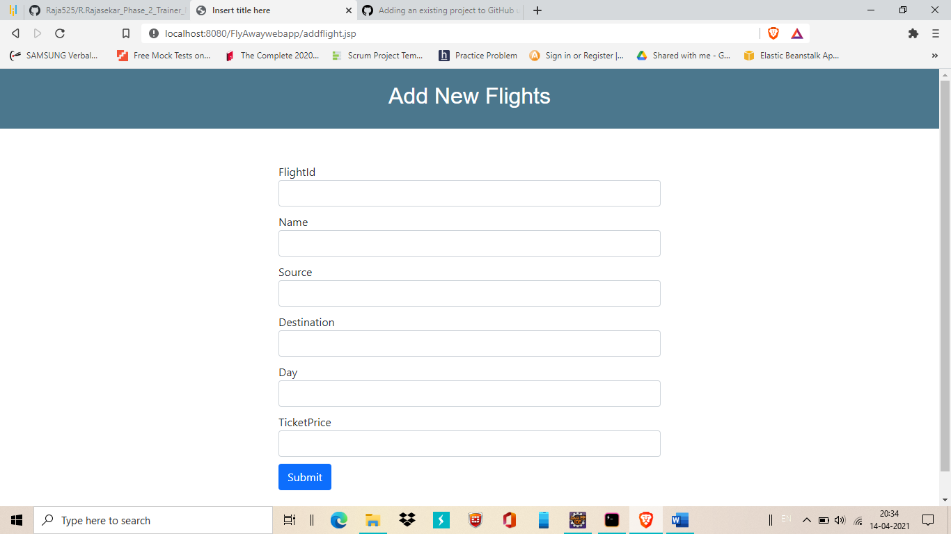

6.Places

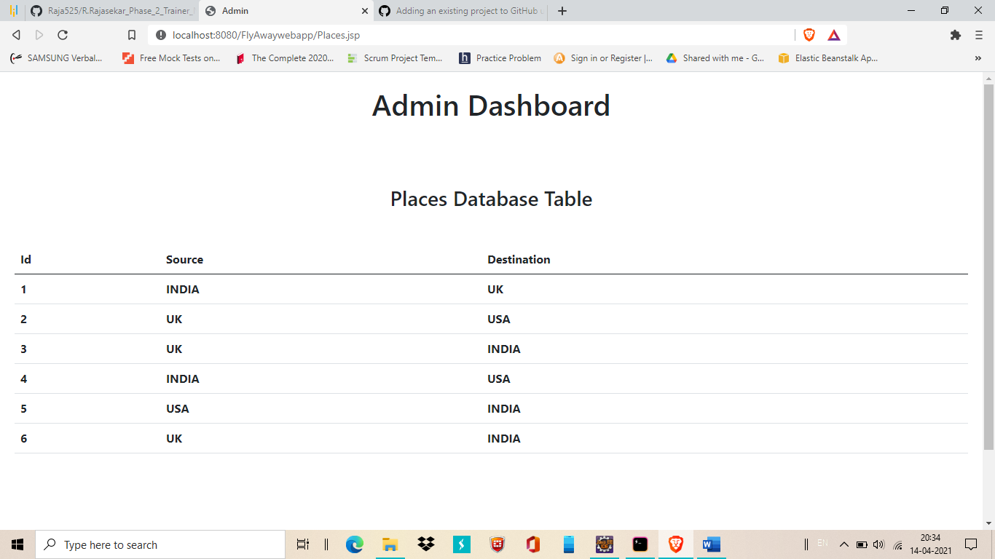

7.Airlines

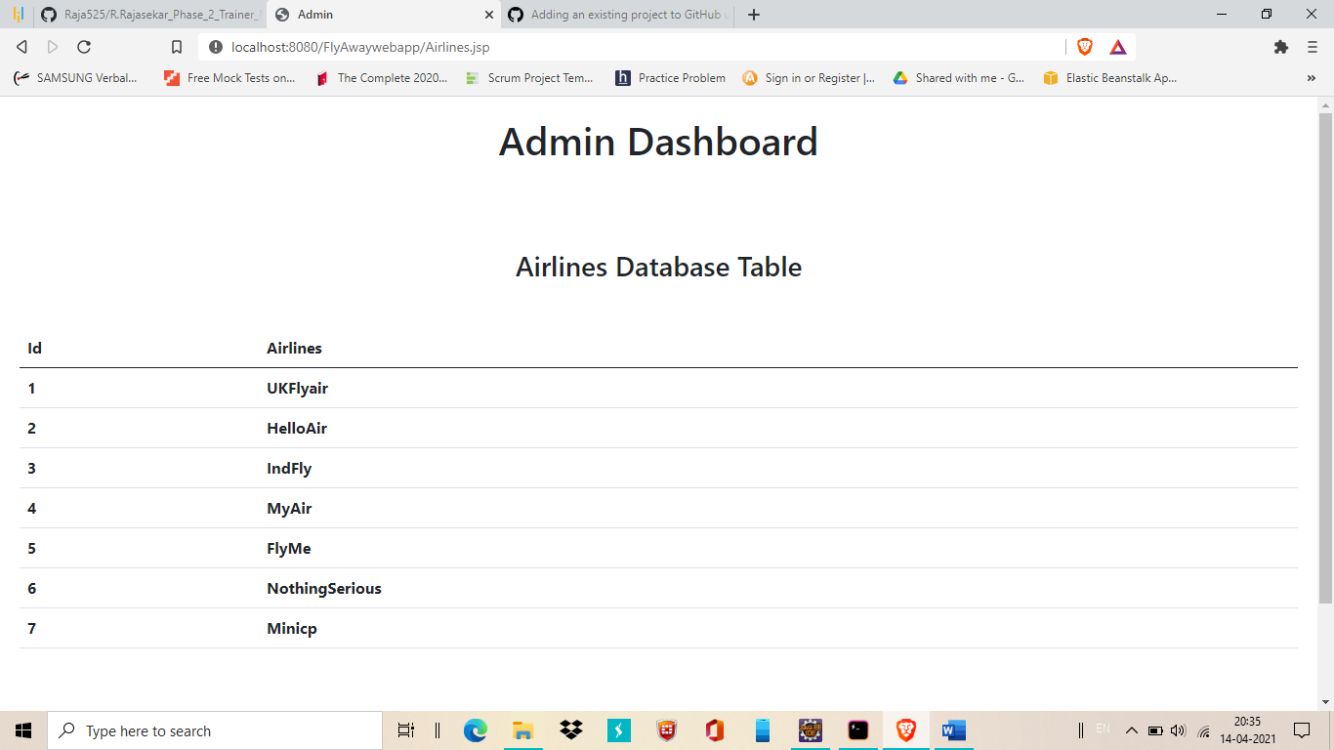

8.Logout button is for return to main page from admin portal

9.click on Book flight option in main page it will display options to select date , source, destination and number of passengers details

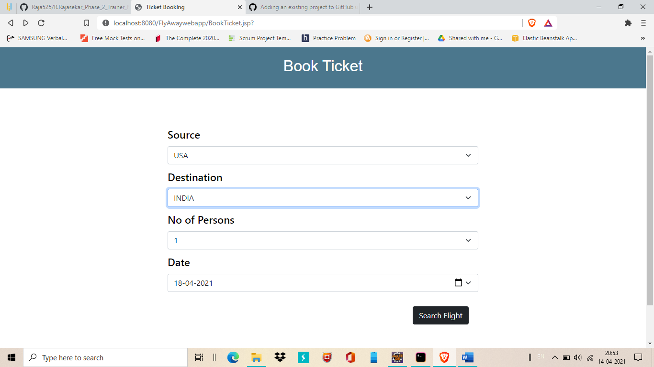

10. you can see the filtered flights and can able to select your favourite flight by click on book flight option.

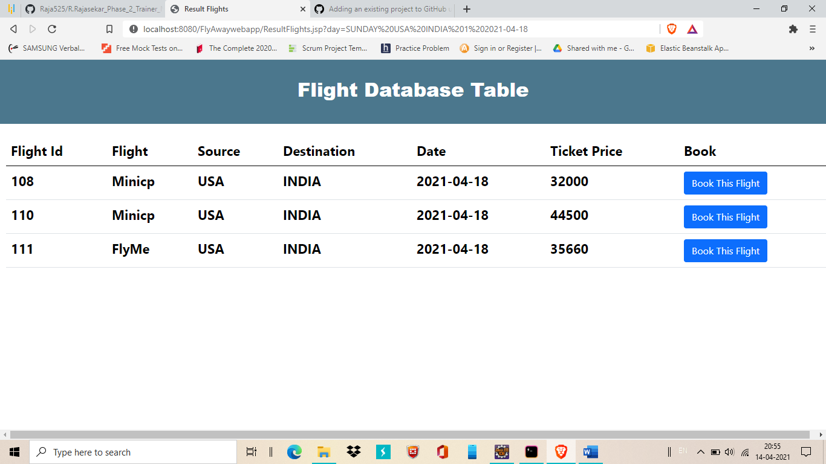

11.Here I choose Minicp airline

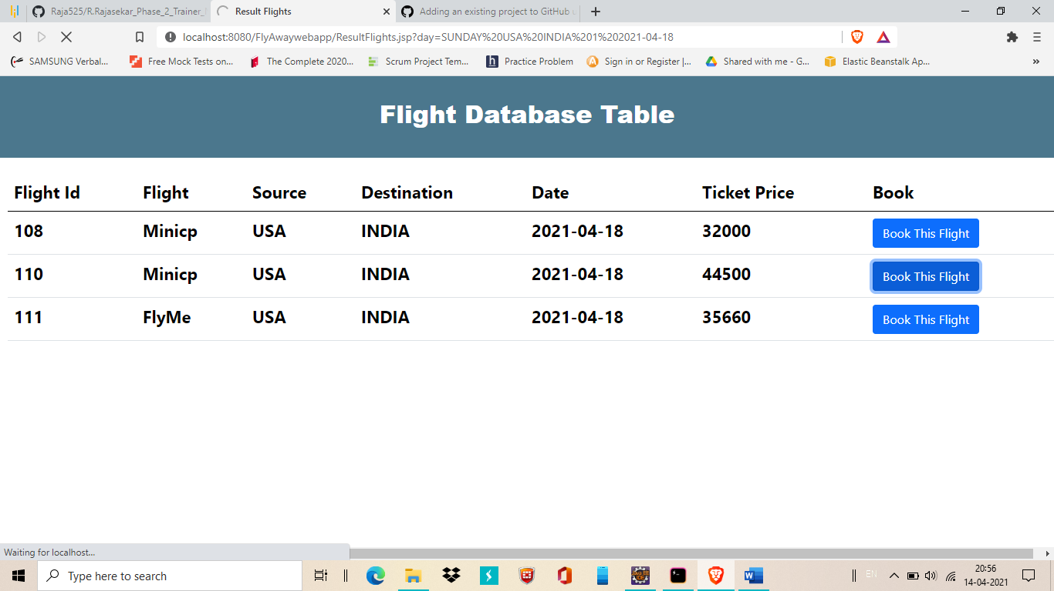

12.customer detail page will be displayed after select your flight. Here you need to enter passenger details

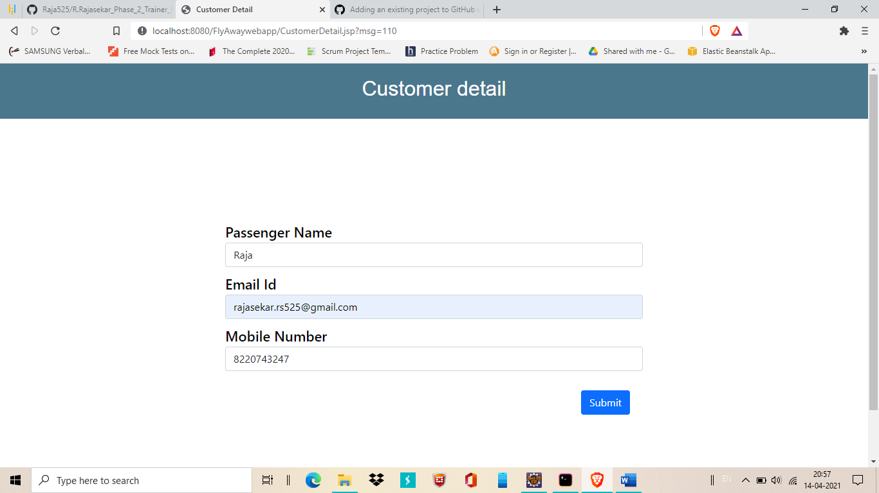

13. After that enter it will redirect to dummy payment gateway. Here you can enter dummy data then enter submit button

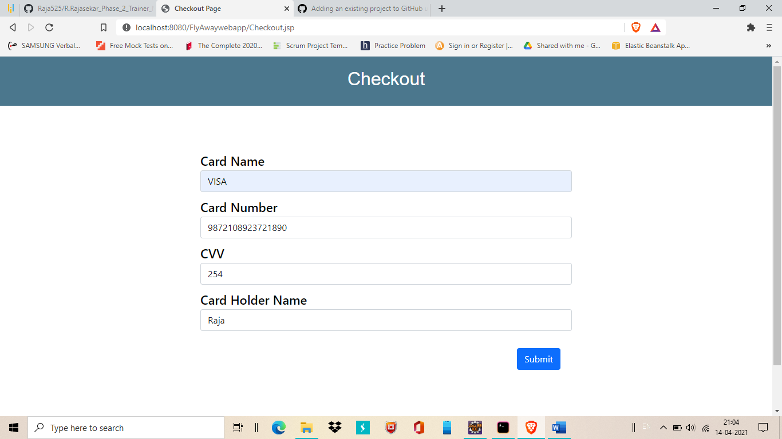

14. After enter payment details it will return a success message, you can able to download the receipt.

